**Therotical Analysis of ESP (Electrostatic Precipitator) for removal of fine particles from stack emission and comparision of results with cyclone**

**By : Aayush Vora(1714063)**

**Sangeet Pandit(1614032)**

**Under the guidance**

**Dr. Siddappa S. Bhusnoor**

**Professor**

**Department of Mechanical Engineering**

**Abstract :**

In this report,we are going to focus on two specific tools to control air pollution namely Electrostatic precipitator(ESP) and Cyclone Seperator.We are going to see the structure and function of both and calculate efficiency of both while varying the particle size and comparing the result and giving the conclusion of the experimental result.

**Introduction:**

Our topic focuses on Air Pollution Control tools namely Electrostatic Precipitator(ESP) and Cyclone Seperator.In everyday life,we get to see industries which emits harmful gases into the air so because of that the tools are used to control the emission of these specific particles using these tools to prevent the air pollution and reduce harming the environment.In these topic we will discuss about the fine harmful particles which ranges between (1 to 100 micro meter)that emits from industries and we will discuss about the tools that are used to separate these harmful fine particles resulting in clean gas that is finally emitted from the industries to the environment.We will take some assumed values and vary the value of size of particle and calculate the efficiency of the mentioned tool and compare the result and discuss the outcome for the same.

**Literature Review:**

1. Louis Theodore,”AIR POLLUTION CONTROL EQUIPMENT CALCULATIONS”,John Wiley & Sons, Inc (2008). We have refferred this book for better understanding of the Cyclone Seperator and Electrostatic precipitator(ESP).
2. M.Bohnet,”Cylone Seperator for fine Particles And Difficult Operating Conditions”,1994.We have referred this for the understanding on how to analyze the given control tools.
3. NPTEL – Chemical Engineering – Chemical Engineering Design – II,”<https://nptel.ac.in/content/storage2/courses/103103027/pdf/mod5.pdf> ”.We have referred this site for design and working of the given control tools.
4. ESP Design Parameters and Their Effects on Collection Efficiency,” <https://ppcair.com/pdf/EPA%20Lesson%20Lesson%203%20-%20ESP%20Parameters%20and%20Efficiency.pdf> ”.We have referred this site for understanding ESP’s parameters and design.
5. Leith, D., and W. Licht, "The collection efficiency of cyclone type particle collectors—a new theoretical approach", AIChE Symposium Series, Vol. 68, No. 126 (1973).We have referred this for the understanding of Cyclone Seperator formula and how to approach theoretically.

**Methodology:**

1. **Cyclone Seperator :**

**Design And Working :**

**Cyclone separators** or simply **cyclones** are separation devices (dry scrubbers) that use the principle of inertia to remove particulate matter from flue gases. Cyclone separators is one of many air pollution control devices known as **precleaners** since they generally remove larger pieces of particulate matter. This prevents finer filtration methods from having to deal with large, more abrasive particles

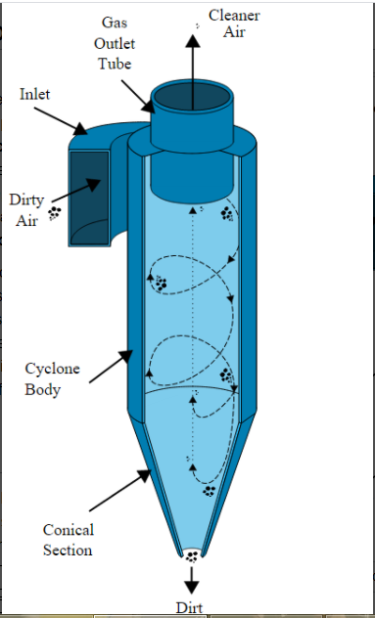

Figure:1-Cyclone Seperator

Cyclone separators work much like a centrifuge, but with a continuous feed of dirty air. In a cyclone separator, dirty flue gas is fed into a chamber. The inside of the chamber creates a spiral vortex, similar to a tornado. This spiral formation and the separation is shown in Figure 1. The lighter components of this gas have less inertia, so it is easier for them to be influenced by the vortex and travel up it. Contrarily, larger components of particulate matter have more inertia and are not as easily influenced by the vortex

Since these larger particles have difficulty following the high-speed spiral motion of the gas and the vortex, the particles hit the inside walls of the container and drop down into a collection hopper. These chambers are shaped like an upside-down cone to promote the collection of these particles at the bottom of the container. The cleaned flue gas escapes out the top of the chamber.

Most cyclones are built to control and remove particulate matter that is larger than 10 micrometers in diameter. However, there do exist high efficiency cyclones that are designed to be effective on particles as small as 2.5 micrometers. As well, these separators are not effective on extremely large particulate matter. For particulates around 200 micrometers in size, [gravity settling chambers](javascript:%20void(0)) or [momentum separators](javascript:%20void(0)) are a better option.

Out of all of the particulate-control devices, cyclone separators are among the least expensive.They are often used as a pre-treatment before the flue gas enters more effective pollution control devices. Therefore, cyclone separators can be seen as "rough separators" before the flue gas reaches the fine filtration stages.

**Advantages and Disadvantages:**

Cyclone separators are generally able to remove somewhere between 50-99% of all particulate matter in flue gas. How well the cyclone separators are actually able to remove this matter depends largely on particle size. If there is a large amount of lighter particulate matter, less of these par0ticles are able to be separated out. Because of this, cyclone separators work best on flue gases that contain large amounts of big particulate matter.

There are several advantages and disadvantages in using cyclone separators. First, cyclone separators are beneficial because they are not expensive to install or maintain, and they have no moving parts. This keeps maintenance and operating costs low. Second, the removed particulate matter is collected when dry, which makes it easier to dispose of. Finally, these units take up very little space. Although effective, there are also disadvantages in using cyclone separators. Mainly because the standard models are not able to collect particulate matter that is smaller than 10 micrometers effectively and the machines are unable to handle sticky or tacky materials well.

**Experimental Analysis**

Finding efficiency while Varying the particle size:

Assuming,

Gas viscosity = 0.02 cP

Specific gravity of the particle = 2.9

Inlet gas velocity to cyclone = 50 ft/s

Effective number of turns within cyclone= 5

Cyclone diameter = 10 ft

Cyclone inlet width = 2.5 ft

Particle Size Distribution Data

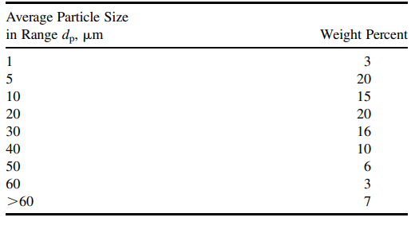

Formula Used :

1. **dpc:**

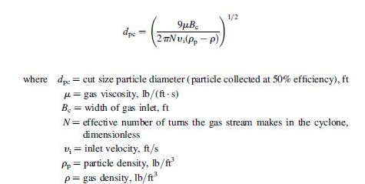

1. **Efficiency:**

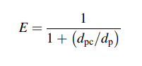

Where, dp = Diameter of particle

1. **Electrostatic Precipitator :**

**Design And Working :**

An electrostatic precipitator is a type of filter (dry scrubber) that uses static electricity to remove soot and ash from exhaust fumes before they exit the smokestacks.This one common air pollution control device. Most power stations burn fossil fuels such as coal or oil to generate electricity for use. When these fuels undergo combustion, smoke is produced.Smoke consists of tiny particles of soot that are suspended in hot, rising air. These unburned particles of carbon are pulled out of the smoke by using static electricity in the precipitators, leaving clean, hot air to escape the smokestacks. It is vital to remove this unreacted carbon from the smoke, as it can damage buildings and harm human health – especially respiratory health.

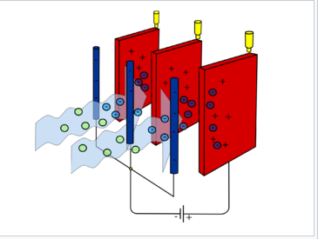

Figure 2 : Electrostatic Precipitator

The operation of electrostatic precipitators is fairly simple. The dirty [flue gas](javascript:%20void(0)) escaping through the smokestack is passed through two electrodes. The shape these electrodes take depends on the type of electrostatic precipitator used, but they can be metal wires, bars, or plates inside a pipe or the smokestack itself. One of the electrodes is charged with a high negative voltage, and this plate causes particulates inside the smoke to obtain a negative charge as they pass by this electrode. Further along the pipe, the second electrode carries a similarly high positive voltage. Based solely on the fact that opposite charges attract, the negatively charged soot particles are pulled towards the positive electrode and stick to it. Occasionally these plates must be cleaned to remove the accumulated soot and dispose of it into a [hopper](javascript:%20void(0)). The soot and ash collected from coal burning power plants in this manner is referred to as fly ash.

Even though most electrostatic precipitators work in a similar way, there are many variations and different types that work better for different sized particles, different smoke compositions, and different amounts of pollution. The need for a variety of designs comes partly from the fact that coal burned around the world varies in its chemical composition drastically. Other power plants may look to remove certain pollutants - such as sulfur dioxide - or look to minimize the amount of ash produced. Additionally, some low-sulfur coals that are burned have a higher electrical resistivity, which makes it more difficult to remove the ash produced by this coal using electrostatic precipitators.

**Advantages And Disadvatages :**

Electrostatic precipitators are extremely effevtive, and are capable of removing more than 99% of particulate matter. Since 1940, emissions of particulate matter smaller than 10 micrometers have been reduced by a factor of 5. However, this high level of effectiveness comes at a high cost - about 2-4% of a power plant's electrical energy output goes into operating electrostatic precipitators and other systems used to remove particulate matter.

The effectiveness of a certain precipitator is determined by how well the specific device deals with the unique features and problems of the plant it is used at. Additionally, precipitator effectiveness is also determined by the temperature and moisture content of the flue gas.

**Experimental Analysis:**

Finding Efficiency while varying the particle size:

Assuming,the cut diameter for a precipitator with a 10 inch plate spacing is 0.9 mm,this particular model will perform with an efficiency of 98% under your operating conditions,the effluent loading does not exceed 0.2 gr/ft^3 ; the inlet loading is 14 gr/ft^3

Particle size distribution table

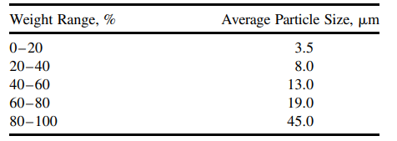

Efficiency,



Here,K can be calculated with the help of cut diameter condition,

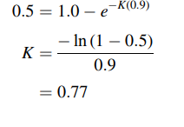

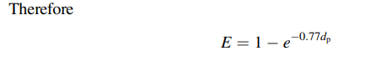

Here,we will Vary the diameter of the formula and find efficiency accordingly,

**Result:**

All the output is converted into graph (efficiency v/s particle size):

|  |  |  |  |  |  |  |  |  |
| --- | --- | --- | --- | --- | --- | --- | --- | --- |
|  |  |  |  |  |  |  |  |  |
|  |  |  |  |  |  |  |  |  |

**Conclusion:**

We have researched the Air Pollution Control tool that are used in industries for particle seperator which removes the fine harmful particles and makes it in a clean air

From, the result we noted that Electrostatic precipitator(ESP) is better than Cyclone Seperator for small fine particles ranging from 1-100 micro meter.

We conclude that Electrostatic precipitator(ESP) is better for small fine particles ranging from 1- 100 micro meter and Cyclone Seperator is used for large particle sizes.

**References:**

1. Lapple, C.E., "Processes use many collection types", Chemical Engineering, 58, 145 (1951).
2. Leith, D., and W. Licht, "The collection efficiency of cyclone type particle collectors—a new theoretical approach", AIChE Symposium Series, Vol. 68, No. 126 (1973).
3. Shepard, C.B., and C.E. Lapple, "Flow pattern and pressure drop in cyclone dust collectors", Industrial and Engineering Chemistry, 31, 972 (1939).
4. Louis Theodore,”AIR POLLUTION CONTROL EQUIPMENT CALCULATIONS”,John Wiley & Sons, Inc (2008).
5. M.Bohnet,”Cylone Seperator for fine Particles And Difficult Operating Conditions”,1994.
6. L. GUAN , G. HARVEL, S. PARK, J.S. CHANG,”Dust Flow Separator Type Electrostatic Precipitator for a Particulate Matter Emission Control from Natural Gas Combution”,11th International Conference on Electrostatic Precipitation.
7. NPTEL – Chemical Engineering – Chemical Engineering Design – II,”<https://nptel.ac.in/content/storage2/courses/103103027/pdf/mod5.pdf> ”.
8. B. Sagot, A. Forthomme, L. Ait Ali Yahia, G. De La Bourdonnaye,” Experimental study of cyclone performance for blow-by gas cleaning applications”,May 2017Journal of Aerosol Science 110.
9. ESP Design Parameters and Their Effects on Collection Efficiency,” <https://ppcair.com/pdf/EPA%20Lesson%20Lesson%203%20-%20ESP%20Parameters%20and%20Efficiency.pdf> ”.
10. Anderson, E. 1924. Report, Western Precipitator Co., Los Angeles, CA. 1919. Transactions of the American Institute of Chemical Engineers. 16:69.